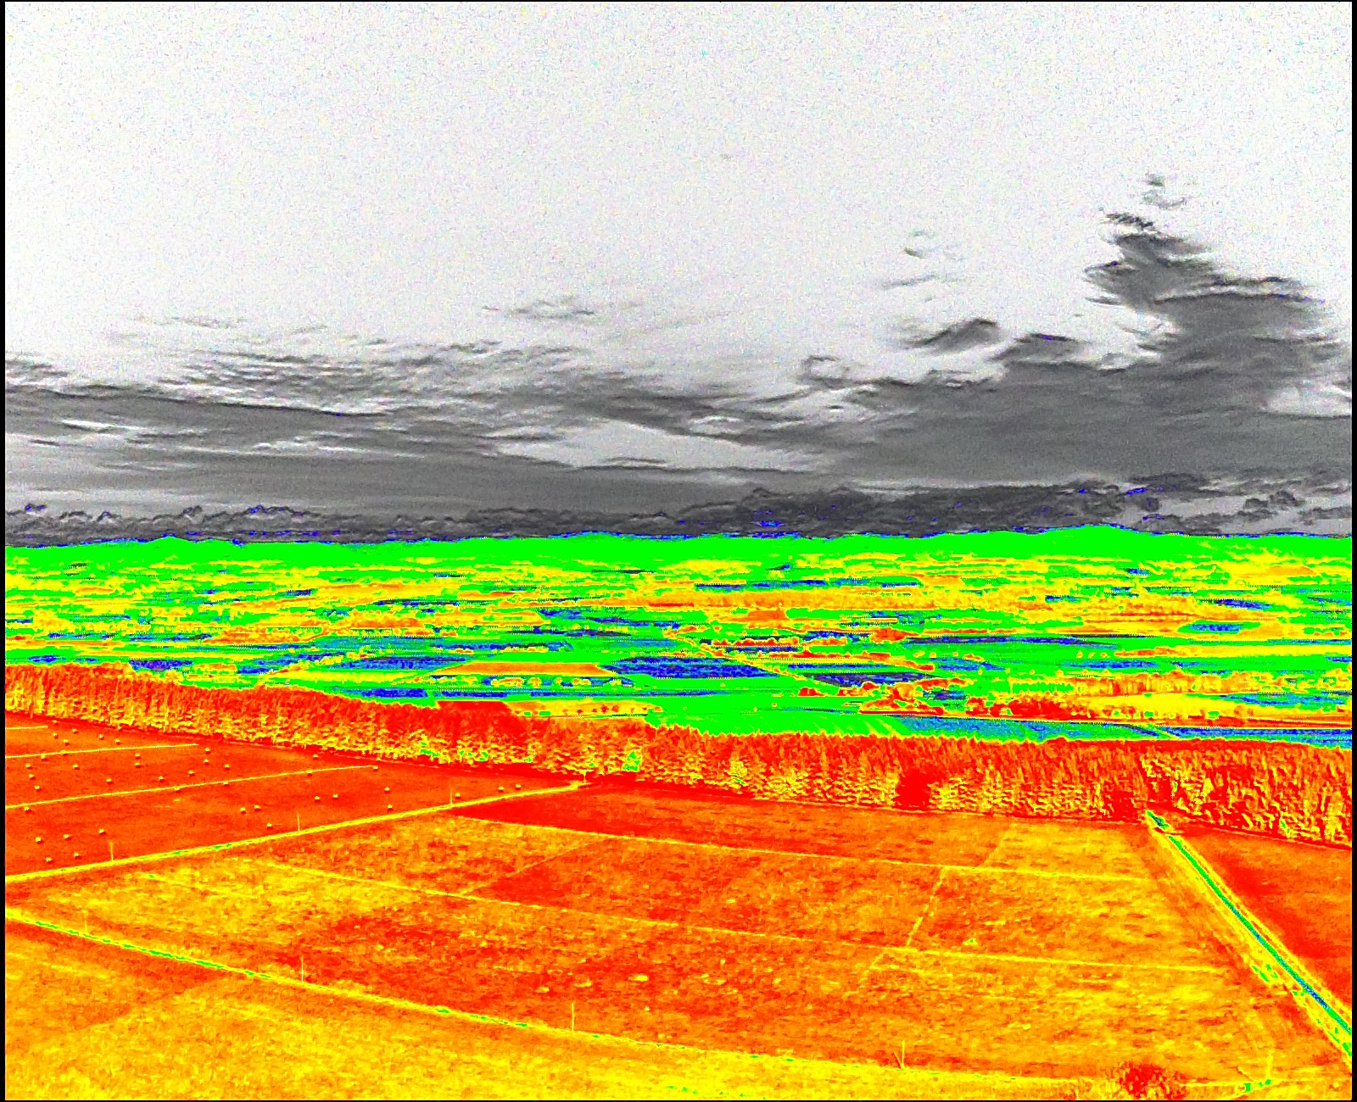

**BIOSOPHERE RESEARCH INSTITUTE**

[**www.biosri.org**](http://www.biosri.org)

**Realizing a better future**

**Dear COP26…**

**An open letter**

Dear COP 26,

Once again, for the twenty-sixth time, the Conference of the

Parties of the UNFCCC meets to discuss its response to the

increasing dangers posed by anthropogenic greenhouse gas

concentrations in the atmosphere. The meeting faces a

number of significant challenges including COVID,

geopolitical tensions and financial pressures. Yet since 1992,

greenhouse gas emissions have continued to climb, with the

COP meetings having no discernible impact.

Meanwhile, the downward trajectory of our prospects marches forward unabated. Yet the key points are that climate destabilization is a threat multiplier and that our context here on Earth is within the Earth system, an extremely complex, connected, emergent, non-linear entity that we are a part of, whether we admit it or not.

 

**The Earth system**

The laws of nature don’t care whether we believe in them or not. If you jump off a cliff you will fall, even if you don’t believe in gravity and if you disturb the Earth system it will respond, even though you don’t believe in systems theory. The reality is that our economies, supply chains, water, climate, food and wellbeing are inextricably intertwined with the Earth system and systems theory sets out the rules for humanity if we are to sustain our co-existence on the planet . We need to know about systems.

These lessons are clearly not at the centre of the UNFCCC at present. This open letter wishes to highlight what the rulebook on systems theory says, and the implications for our path ahead.

There are six key points that we feel require urgent attention in order to realize the fundamental ambitions of not only the UNFCCC, but of the vast majority of the human race.

All of these things are clearly understood by many, including the indigenous populations remaining on the planet.

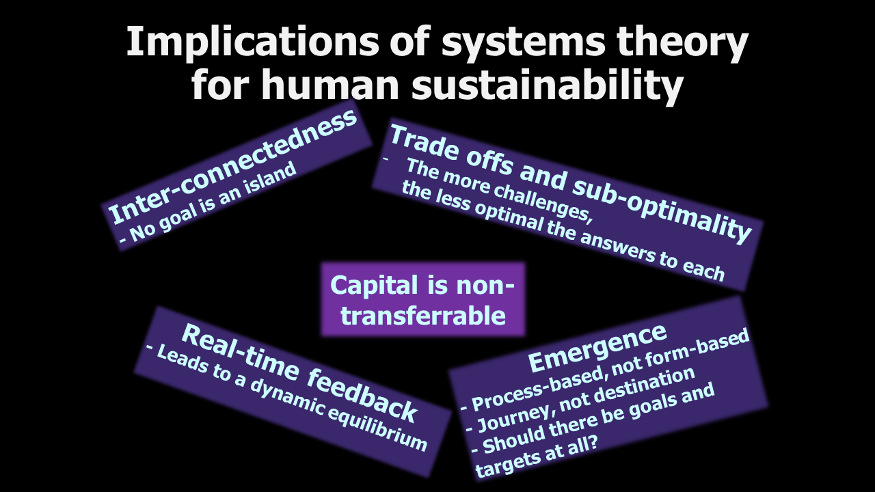

|  |
| --- |
| **Six key messages for COP26**  **1. The Earth system lies at the heart of everything.** It is:  **HIGHLY COMPLEX**: reductionist approaches will not work and silos must be avoided.  **EMERGENT**: the properties belong to the whole, not to the parts. We can only operate within it, not on it.  **NON-LINEAR**: tipping points and regime shifts can occur suddenly and irreversibly.  **SELF-ORGANIZING**: The Earth system has built and re-built itself many times over 3.8 billion years. All we can do is to allow it to self-heal by taking our feet of its throat, hoping to avoid a system reset.  **SUB-OPTIMAL**: No component should optimize for itself. Trade-offs are a sign of a healthy working system. We need to look at what we can relinquish. Silos prevent such trade offs and must be avoided.  **RELIANT ON REAL TIME FEEDBACK**: Emergence comes from connectivity. We must re-connect, assisted by the internet of things and AI, to find the right level of sub-optimality for our species. |



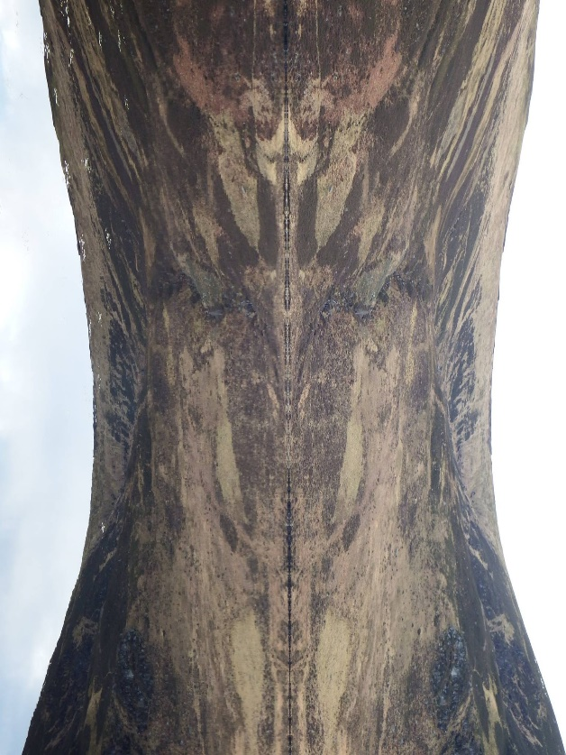

**2.** **Carbon fixation: It’s not just carbon, stupid**

We can ill-afford to ignore other pressing issues: soil erosion, soil salinization, eutrophication, habitat destruction and biodiversity collapse. We must address all of these together. Many renewable energy technologies create significant issues – 50% of cobalt in EVs is produced using child labour. Lithium extraction impacts water purity. Rare earth metal extraction impacts child health. All of these issues can be addressed (see our report: ‘The dark shadows of the jolly green giants’).We can do much better and we must multi-task, because we exist in a multi-dimensional Earth system.

**3. The 3 R’s: Reduce Reduce Reduce**

Swapping black energy for green energy is not the solution – it only maintains our other bad, high-energy habits, allowing business-as-usual minus the carbon. By reducing resource use, we can reduce the intensity of our extractive processes in industry and agriculture, allowing more sub-optimality back into the system, so essential for Earth system recovery. The emphasis must be on **REDUCTION**.

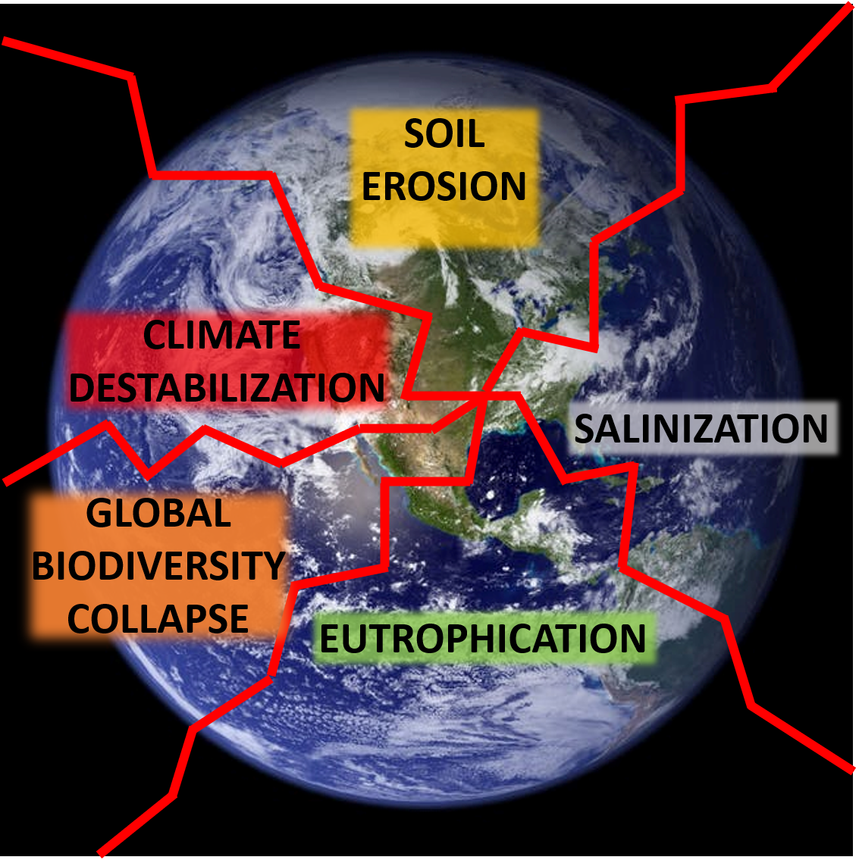

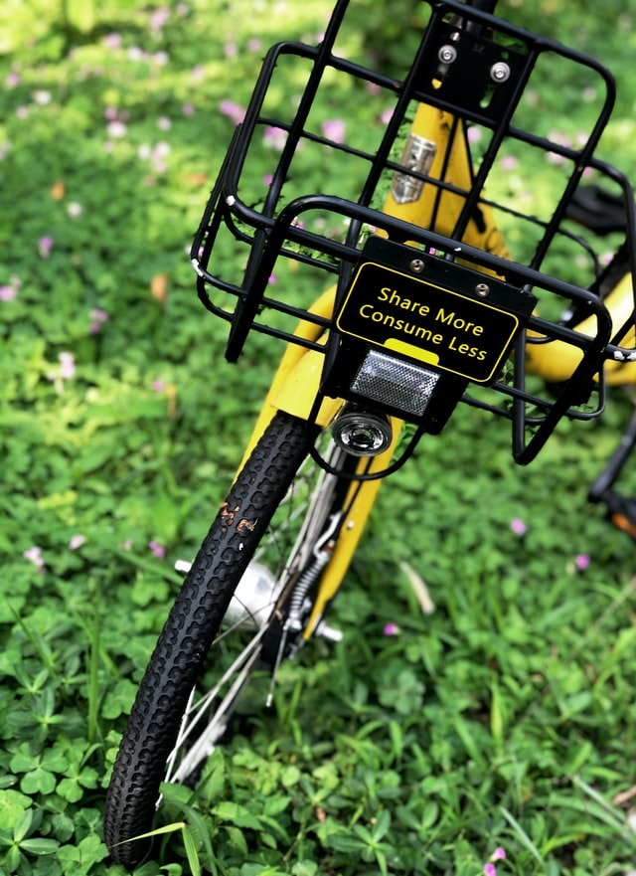

**4. Embed the economy**

The ecological footprint, not the carbon footprint, must be used to value our economic activities, aiming at net negative, not net zero, from everything including carbon, habitat, eutrophication, soil erosion and salinization. Only Nature can restore itself, so our economic activities must liberate the Earth system to self-heal with us as part of the recovery, practicing a symbiotic, embedded economy in resonance with and directed by the Earth system.

**5. Empower the people**

The planet is in the state that it is due to billions of individual decisions. As consumers, we need individual accountability, but that means that we need supply chain transparency. At present we don’t know if our EV contains cobalt from child labour, or if our clothes were made by children exploited in dangerous factories. The internet of things can provide complete transparency in our supply chains. We also recommend shortening supply chains, bringing the local back into the economy, embedding it within our own landscapes and communities. We need slimmer, faster, smaller economic circles. Thus empowered with knowledge, we can then be accountable and will make the decisions ourselves that will save our planet.







**6. De-politicize the process.**

We cannot deliver anything if we are on opposite sides of the ballot box, nationally and internationally. The stakes are so high that we need a unified approach, bringing together everyone with a common goal. The role of government is to facilitate this. It’s time to let go and work as one. We haven’t got time for bickering and power games. A unified directorate, with citizens, business, industry and civic leaders working together with politicians and across all nations is an essential priority, freeing us from barriers.

These six points are detailed in the following book, awarded a prestigious OAT award from the American Libraries Association: **K.R.Skene (2019) Artificial Intelligence and the Environmental Crisis: Can Technology Really Save the World. Routledge.**

We hope this proves useful as you meet in Glasgow. Visit us at www.biosri.org.

Yours sincerely,

The Biosphere Research Institute.





**Who we are**

**The Biosphere Research Institute (BIOSRI) is a collaborative, global, virtual, not-for-profit centre of research and resource, addressing the wicked problems facing humankind, by breaking out of the silos of traditional academia and bringing together the best minds in the world to collaborate, while sharing resources, in order to catalyse change. We also provide residential, non-residential and online courses for business, academia and the wider population globally. Visit our website for more details of what we do.**

**Contact Us**

**Dr Keith R. Skene, Director**

**Biosphere Research Institute**

**Email: krskene@biosri.org**

**Web: www.biosri.org**